Operations Processes

OP Category | MOC |  | Operation Process
Execution Mngt | Production | Create/Modify/Delete Production Order from business
Execution Mngt | Production | Create/Modify/Delete Production Order from Shop Floor
Execution Mngt | Packaging | Create/Modify/Delete Packaging order from business
Execution Mngt | Inventory | Create/Modify/Delete Transfer Order from Business
Execution Mngt | Inventory | Create/Modify/Delete Transfer Order from Shop Floor
Execution Mngt | Production | Execute Production Order
Execution Mngt | Inventory | Execute Transfer Order
Execution Mngt | Quality | QC – Product quality management
Execution Mngt | Quality | QA – product release
Resource Mngt |  | Publish Equipment Failure Report per period
Global Operation Mngt
Global Operation Mngt |  | Publish shift/daily/Monthly/Yearly Production Report
Global Operation Mngt |  | Publish period utility report
Global Operation Mngt |  | Publish average yield per product/period
Master Data Def./Sync |  | Create/Modify/Delete Product Definition
Master Data Def./Sync |  | Create/Modify/Delete Quality Control Plan
Master Data Def./Sync |  | Create/Modify/Delete Quality Test definition
Master Data Def./Sync |  | Create/Modify/Delete Work Segment
Master Data Def./Sync |  | Create/Modify/Delete Equipment Class
Master Data Def./Sync |  | Create/Modify/Delete Equipment
Master Data Def./Sync |  | Create/Modify/Delete Personnel Class
Master Data Def./Sync |  | Create/Modify/Delete Person
Master Data Def./Sync |  | Create/Modify/Delete Material Class
Master Data Def./Sync |  | Create/Modify/Delete Material Definition
Master Data Def./Sync |  | Create/Modify/Delete

Business process description

Example 1 : Create Production Order

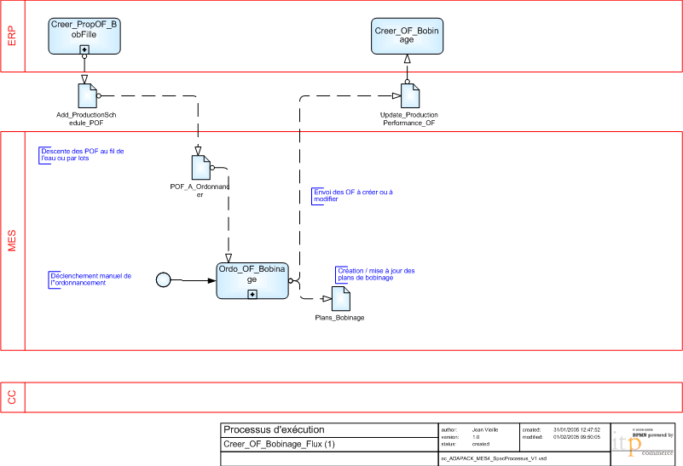
Exemple 2 : Collect operations execution data

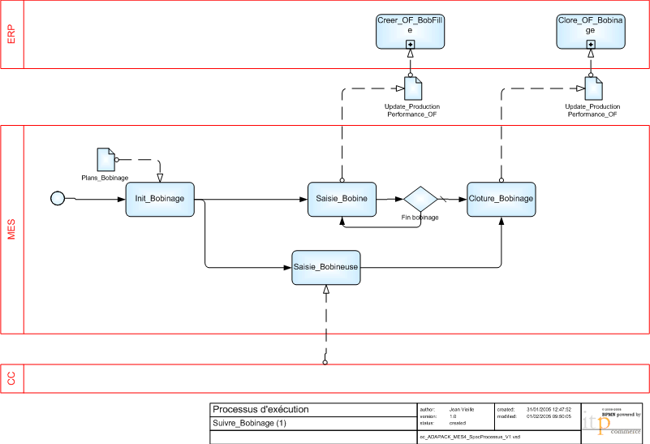

Task list

Generic Activity | Task
Scheduling | Generate detail production schedule
Scheduling | Generate detail packaging schedule
Scheduling | Generate detail picking schedule
Dispatching | Create / modify Work Unit dispatch list
Execution | Print label
Execution | Check material input
Execution | Material reconciliation
Resource management | Update equipment status
Resource management | Release material lot
Resource management | Update personnel availability
Definition management
Data Collection
Tracking
Analysis

