Performance management for Digital transformation

Jean Vieille
SyntropicFactory, Control Chain Group, Interaxys
j.vieille@syntropicfactory.com

03/2016
Abstract.
Increasing dynamics of industrial production (supply chain volatility, new products, re-engineering of facilities and organization) is both caused and addressed by information technologies. The IT world keeps inventing new technologies; analysts publish alarming maturity benchmarks; obsolescence is exacerbated by security concern, spare parts and skills shortage. Industrial IT needs to follow this ongoing transformation of enterprises and to take advantage of new IT technologies.
Digital transformation has become a well-established motto that is often presented as a comprehensive IT re-engineering project. In reality, CEOs and CIOs are less enthusiastic considering the risks, cost and feasibility of such a big-bang approach. They perceive myths and hypes behind so-called new technologies, but wish to leverage real opportunities to provide the best informational support to operations and development of their enterprise given their available means.
Shifting back the digital transformation project paradigm to an ongoing IT development process will make room for guiding efforts to support enterprise success and implement new technologies pragmatically and efficiently. In our thesis, performance management can help rationalizing this process if it links digital transformation process metrics to global enterprise achievement. Properly managed digital transformation performance shall help to prioritize requirements, set appropriate budgets based on acceptable latency of IT requirement fulfilment – digital/enterprise transformation ratio.
This article describes a method for realizing this linkage by leveraging relevant systems, information and management theories: Control Chain Management Reference Model, Viable System Model, Performance cybernetics, Overall Interactional Effectiveness encompassing 6 Sigma, Lean management and Theory of Constraints.
This article features a partial use case while this work is supported by limited implementations. It needs more experiments and developments to become a fully actionable.
Keywords: IT Transformation, Performance, Management, Investment, Entropy, Complexity, Viable System Model, Fractal Enterprise, Behaviour control, Conflict resolution
- Introduction
The physical goods industry is still at the heart of the Society in a hyper connected World, increasingly virtualized. Information technology raises steadily its contribution to facilities management, operations and development to address its more and more challenging dynamics (supply chain volatility, new products, re-engineering of facilities and organization). On the other hand, information technology keeps innovating and improving software capabilities, infrastructure as well as development and implementation methods.
The IT world keeps inventing new technologies; analysts publish alarming maturity benchmarks; obsolescence is exacerbated by security concern, spare parts and skills shortage. In this context, the Digital Transformation paradigm has emerged with the promise to magically propel the enterprise success and distant laggard competitors.
When observing the long trend of information technologies evolution, we don’t see demonstrated proofs of recent accelerating IT innovation. Moore’s law density does not match smartness trend, information technology transitions from handwriting, printing, electrics, analog electronics to current silicon based digital electronics represented quantum leaps that largely match recent breakthrough innovations: Internet of Things, Big Data, Mobility, Virtualization appeared progressively since a decade.

Digital Transformation has been coined very recently as a new paradigm for a large mandatory project for enterprises to survive by taking advantage of these alleged new technologies.
This is not to denigrate the Digital Transformation, nor technologies: our point it to emphasis its timeless criticality. Enterprises are wise enough to sustain their development by continuously investing in technologies that allow them to satisfy their objectives: Digital Transformation has been part of this effort since IT inception. From a more comprehensive and holistic perspective, enterprises simply need rationalizing resource spending and focusing their efforts in information technologies to best support their operations and development. Digital transformation is a continuous development process that always exists implicitly or explicitly, not necessarily needing a large one-shot strategic program to implement a determinate ambitious blueprint.
Improving the effectiveness of this process shall lead to better address business requirement, using technology as an enabler, considering objectively the last relevant coordinated incentives and hypes – Smart Industry, Industrie 4.0, Industrie du Futur; IoT, Big Data, Mobility, Social networking, Blockchain...

Driving a digital transformation process requires two fundamental types of decisions.
How much resources to allocate, budget setting
Common practice is to set IT budgets close to industry sector’s average. This conservative attitude necessarily leads to excessive or insufficient spending.
How to dispatch resources, spending
Requirements and projects priorities result from negotiation play where the most insisting and convincing manager gets all. This applies to strategic initiatives too.

These decisions cannot be made determistically by straightforward optimization calculation: it is impossible to determine the best choice nor to assess a posteriori that the best decision was made.
Performance management is one way for orienting decisions toward a statistically more favorable outcome by seeking effective use of resources to reach objectives. At the enterprise level, objectives seek to determine conditions for its success as a whole. At intermediate levels like digital transformation, local objectives need to contribute to achieve enterprise objectives.
This article explores a performance management scheme that links requirement fulfilment to enterprise success. This allow effective priority setting for sorting requirements and informed investment decision to reach an acceptable transformation latency (i.e. by implementing new technology).

The article shall be considered as a study framework overview, that need to be complemented by more focused, elaborated and demonstrated works.

Section 2 presents background considerations, theories and studies on which this performance management scheme is based.
Section 3 describes the proposed performance management scheme for driving digital transformation
Section 4 discusses certain aspects and difficulties linked to this scheme
Section 5 presents a use case that illustrates some aspects of the scheme

- Related considerations, theories and studies
  - Role of information in industrial systems
This study seeks to establish a deterministic, quantitative approach for the development of information technology. This approach will prove the usefulness of this technology based on specific explicit requirements and functional claims. This narrow perspective sets information technology as the mere support to operations. At this point, it is useful to remind the fundamental nature of information, specifically within the intrinsic “physical” industrial World to emphasise the importance of digital transformation - though technology addresses only part of information aspects.
Information is a peculiar extensive concept that is involved in any others if only because the concept of concept is purely informational. It is not a fully qualified physical entity until it reifies into some tangible or deductible manifestations (a static printed page, Bosons…).
Somewhat like energy[1] Information exhibit potential aspects like: things and facts (the “reality” shaped or made of information), data (localized transduced measurement of reality), meaning (deductive interpretation of data), knowledge (created understanding based on meaning) and consciousness (subjective orientation of understanding). It also exhibits kinetic aspects: interactions between “real” subjects, communication (distant interactions), Processing (maths applied on information), intelligence (complex processing for driving understanding to reach goals), wisdom (adaptation to complex situation)[2].

In the context of an industrial systems information is ubiquitously pervasive, driving physical transformations and displacement processes as well as linking and tightening together the multiple components (departments, people, parties… structure and behaviour) of the inherently complex industrial system.
It mixes with matter and energy to make products. In this statement, the difference between matter and product is the decrease of entropy, or increase of order, structure. As the World entropy is supposed to be constant or increasing, the entropy deficit caused by industry is compensated by energy decay and information brought in the process (negentropy).[1] In the same way that energy harnessing and machines multiplied biological power at the start of the industrial age, information technology propels biological information processing, multiplying human minds capabilities, allowing to deliver more efficiently smarter products in smarter ways. As production and consumption compete for better offering and higher expectations (service, quality, price), industry must follow this ever upward trend (there is no limit to smartness) to survive (Fig. 1.).
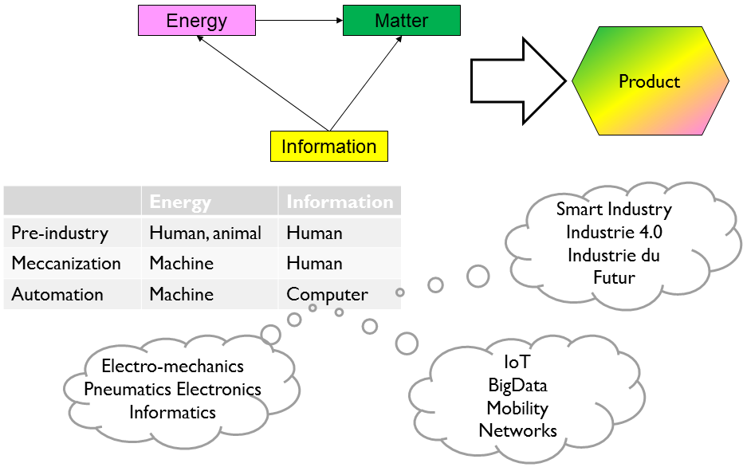
Fig. 1.

2.2 Digital transformation process reference model
We assume that Digital transformation is a process that handles the ongoing development (implementation, maintenance, improvement) of information technology and that always exists in any enterprise. Such an assumption means a subjective observation that does not necessarily matches existing organizations. A reference model defines an analysis framework for sharing understanding and standardising measurements.[3]
The Control Chain Management (CCM) framework [4] represents the ongoing IT transformation process of an industrial system. It highlights the following aspects that may or may not be explicitly defined, managed and operated. (Fig. 2.):
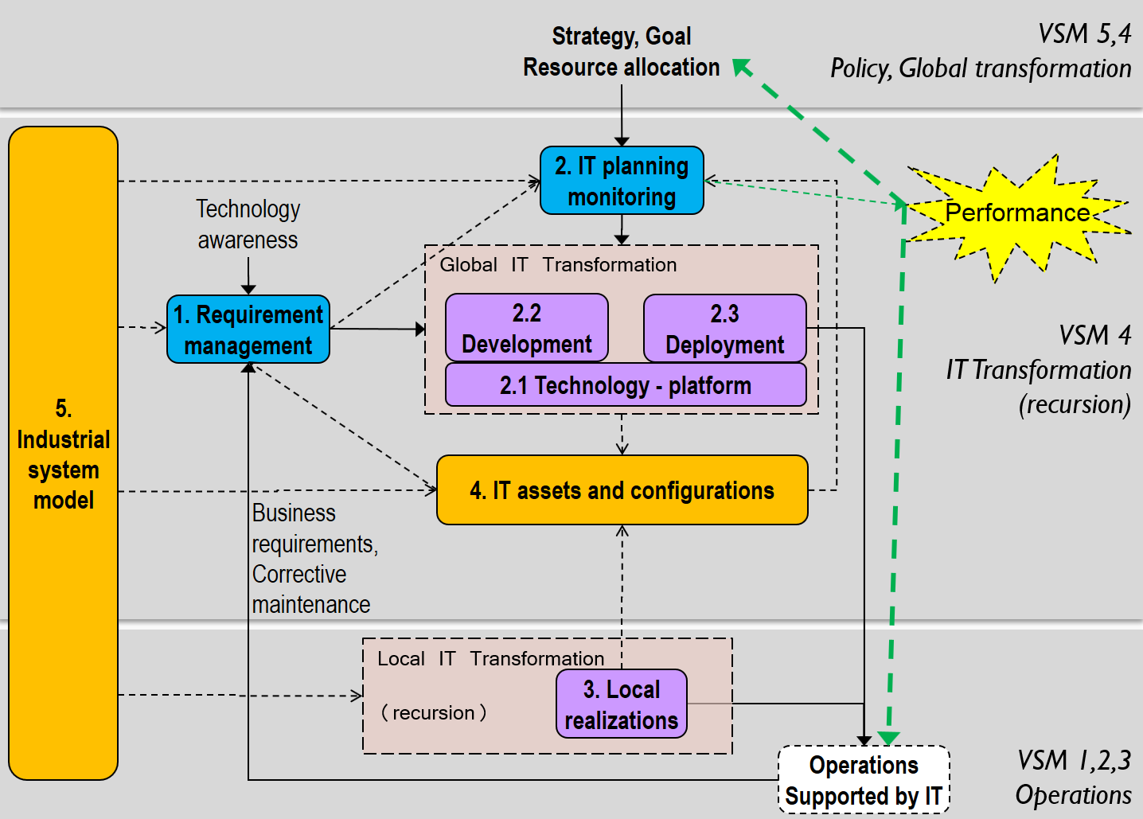
Fig. 2.

Requirement management.
This part of the process provides the inputs for IT delivery. Requirements come from different sources that fall into two categories:
- the needs for serving the business to improve operations or to achieve the desired transformation (actual requirements or corrective maintenance); these requirements are driven by operational demand.
- technology awareness and current IT asset status to facilitate the fulfilment of business needs and leverage new technologies; these requirements are pushed by development will.
There are many ways for gathering, classifying, processing requirements before they can be considered for implementation[4]. The outcome of this process is a validated, valued, and prioritized backlog of requirements to be addressed.
As inferred above, business related requirements include both new or replacement functions as well as corrections / improvements: there is a constant need for adjusting, improving the delivered IT. Corrective maintenance adapts existing applications, functions, configurations to improve usability, productivity or to match context changes (product, facilities, people). It is presented as a variant of IT transformation inputs: actually, there is continuum from large, long lead time projects, handled at a high level in the enterprise to responsive, simple parameter adjustments (possibly addressed locally through small local projects, dedicated resources mentioned as “local realizations” – see below).

IT planning and monitoring.
This main process manages IT activities as large projects and / or continuous incremental delivery (Agile, DevOps, Continuous delivery…). These activities address three main areas:

2.1 Technology – platform
implements hardware and software as available resources for addressing business requirements.

2.2 Development
addresses business requirements by implementing corresponding functions regardless the specific users and processes that triggered the requirements.

2.3 Deployment
delivers the developed functions to target users and processes.
The planning itself is oriented by the enterprise strategy, driven by the requirements and constrained by allocated resources.

Monitoring includes performance management of the transformation process.

Local realizations.
This process is not totally centralized. In many enterprises, IT delivery is structurally, partially dispatched closer to business departments. This may correspond to a deliberated organisational choice, or can be motivated by difficulties to articulate and justify requirements, slow or denied central IT response.
These local activities are IT transformation processes at a lower level of recursion. They can be more or less independent, linked to the upper level process on different aspects (platform, assets, models, resources…). This split can help addressing complexity management – providing it is correctly implemented (see later). The recursive structure of IT delivery does not necessarily match non-IT organization entities.

IT assets and configurations
Managing transformation implies a sufficient knowledge of the existing IT assets and configuration history: hardware, operating systems and general service applications (users’ identity and permissions, database servers, message brokers…), network and connections, business applications and their configuration.
Any activity relies on and impacts this repository that has to be maintained in sync with the actual situation.

Industrial system model
Identifying requirements, planning activities, localizing IT assets and deployed functions needs to be clearly linked to the industrial system through an appropriate formal representation. It is structured around resources (material, equipment, people…) business and physical processes. Standards like ISA-95 offer possible meta-models for this representation.

2.3 Enterprise complexity and control
An enterprise can be seen as a complex purposeful system[5] that is made of interrelated subsystems such as functional entities like HR, Marketing, R&D, Engineering, IT, Sales, Sourcing, Planning, Production, Logistics, Finances, Communication… or organic entities like business unit, plant, distribution centre… It interacts with the supra-system it is part of, that we call “environment”. This environment materializes through miscellaneous parties the enterprise interacts with such as Suppliers, Customers, Contractors, Partners, Employees, shareholders, Bankers, Insurers, Market, Politics, IRS, Regulations, Macroeconomics, Natural, and Social environment… Obviously, this environment is highly complex, actually much more than the enterprise.
This enterprise seeks to achieve goals, for example “Reward shareholders for their capital investment”. It is both difficult and feasible.
It is difficult because the enterprise has to cope with sensitive trade-offs to satisfy its environment stakeholders, unless the supra-system will simply eliminate it: customer will find alternate sources, best employees will move to more rewarding companies, bankers will cut credit lines, shareholders will cease supporting investments, authorities will prohibit the operation of the polluting factory… requiring seemingly contradictory decisions. It is difficult because the enterprise itself has the same problem internally to balance and coordinate interactions between all its departments, people, machines, in parallel with direct decision hierarchy that propagates down from simplistic high level orders to highly complex operational realization. Fig. 3. represents the related complexity of the environment and enterprise as a cloud (complex shape) and a circle (simpler shape).
Fig. 3.
It is feasible because the enterprise manages to handle this complexity by fulfilling the W.A. Ashby’s Law of requisite variety[6]. This theorem is well known by automation engineers: a controlling system must match the variety (degrees of freedom) of the controlled system. The enterprises use variety amplifiers and attenuators to realize this matching.
For example, reducing the numerous, dissimilar customers into market segments is a variety attenuator that reduces the innumerable individual customers to a small set of typical entities. Conversely, market segmentation amplifies the effect of adjusting products features and prices by the number of targeted customers.
Internally, management knows little about actual operations it drives. For the sake of controllability by management, operations need to be tightly controlled to act appropriately on simplistic orders – which mean autonomy, responsibility, rules and capability. This allows operations to appear as a lower variety, easily controllable entity from management viewpoint (matching variety), to the expense of increased internal control. IT department decentralization and split mentioned above is a complexity management feature that enables local autonomy for addressing parallel domain specific demands.
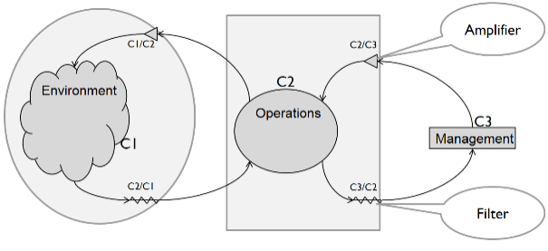
Fig. 4.
Fig. 4. Shows the environment “cloud” connecting to operations “circle” through variety attenuators and amplifiers, making possible for operations to match higher environment variety: it appears like a “circle” for operations. Simplistic management is represented like a rectangle, that needs to see higher variety operations circle like a rectangle, which is similarly achieved by variety attenuation / amplification.

Practical means to match complexity
The above consideration relates to Direct control: a manager gives (simple) instructions to the managed entity that executes (complex) realization by adding its embedded knowledge and experience, referencing rules and best practices. This can work thanks to the proper organization, rules, best practices and decision enforcement.
This is of course not enough because there are always many ways to do the same job, by respecting to the letter the given instructions. As complexity is synonym of lack of knowledge of the observed thing, the explicit, standardized knowledge is only one part the objective knowledge[7] involved for obtaining a given quality range result. The relatively controlled product variability (quality) contrasts with the high variability of the possible means for this achievement, opening ways for optimization (performance).
If obtaining an acceptable outcome is somewhat possible by Direct control, it is insufficient for optimal operations, to keep the system alive, to improve it: sooner or later, lack of efficiency, product variability, inacceptable waste, improper coordination will make it irrelevant.
Take the example of running a Country, which is a highly complex system. The President is a human being who has to control millions of other human beings, every one of them with his own purpose in life, goals, character. The country achieves naturally direct control by variety reduction. Organization recursively splits the country functionally and organically into ministries, states, regions, cities, families… Law reduces variety by theoretically constraining the behaviour of people and the relevant organisations they are part of. Because constraints are not readily accepted, law enforcement is implemented by police and justice.
As it is impossible to tightly control every aspect of operations – or to make citizen socially effective by decree, one needs to compensate this lack of complexity in the direct control chain. For example, Countries may address this issue by promoting religion (that instils social instinct and fear of invisible, infinite power) or equivalent beliefs in order to achieve behaviour control. Behaviour control aims at providing subliminal guidance to self-orient people actions toward superior interests beyond their own. Behaviour control can be implemented by numerous means: Rewards, Incentives, Motivation, Team spirit, Advertisement, Propaganda, Brainwashing, Threat, False flag, Concealment, Leaked secrets (no secret leaks which are counter-productive), Corruption, etc. The objective is to trigger emotional strings in order to encourage, excite, influence, subjugate. The complex, opportunistic behavioural/emotional inducement is a huge complexity amplifier that significantly complements simplistic, deterministic, complexity filtering direct control (Fig. 5.).
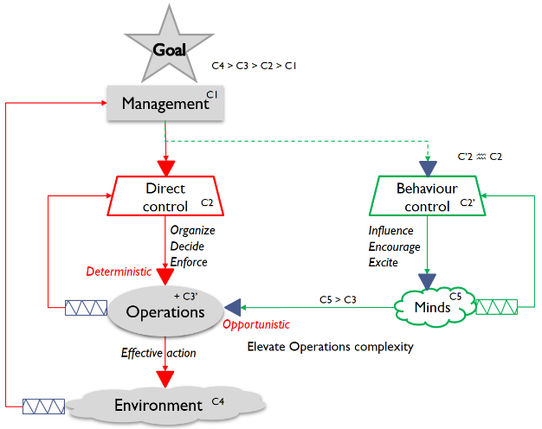
Fig. 5.

Back to enterprises, behaviour control is achieved by many different means, instilling corporate culture, achievement, change management. Performance management is an effective and popular behaviour inducer to orient people and organizational entities toward desired attitudes.

2.4 Viable system model
The Viable System Model was developed by Stafford Beer in 1970’s[8] [9] [10]as a systemic tool for analysing organizations through the analogy of natural organisms and respect to complexity balance. Not entering in the details of this 1000 pages’ theory, we will present through examples only relevant aspects for this study. Fig. 6. represents the enterprise as 5 “systems” that are essential for a viable organization.
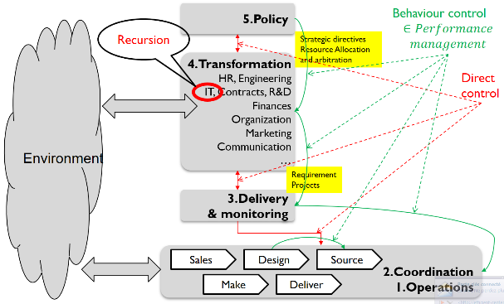
Fig. 6.
System 1 corresponds to the operations, where the organization fulfils its role in the supra system. For an industrial enterprise, operations can be represented functionally (sales, source, make, deliver, design… processes) and organically (business unit, plant, distribution centre…).
System 2 coordinates operations, ensuring stability of interacting system 1 entities. For an industrial enterprise, it corresponds to various scheduling functions that makes production, maintenance, inventory control and quality interacting appropriately. For the context of this study, systems 1 and 2 are generally represented together (Coordination & operations”).
System 3, 4 and 5 makes the “meta-system” which is the management part of the organization, driving operations. System 3 manages the delivery of the organization services and products by directing operational input/output flows. For an industrial enterprise, it corresponds to the enterprise resource planning (ERP) in the functional sense, the Plan process of the supply chain operation reference (SCOR) model.
System 4 is in charge of transforming the organization to adapt its nature to the changing environment and to achieve its objectives. It tightly interacts with the environment to induce the relevant changes as a vital activity of the organization. Transformation covers all aspects of the organization’s nature. For an industrial enterprise, it corresponds to non-delivery, development oriented activities like engineering, research and innovation, marketing, communication, finances, long term contracts as well as adaptation of human resources, organization engineering.
System 5 manages the organization identity, setting goals and strategic objectives. It ensures consistency by addressing the proper interactions between system 4 and system 3, balancing the resources for transformation versus operations.
Interactions between these systems need to comply with the law of requisite variety; Fig. 6. shows direct and behavioural controls between the different systems.
A living (viable) organisation is not that simple. this general model is actually a recursive model, even a “fractal” one[11]. For example, an industrial enterprise can be split into business units with their own governance and bounded autonomy within the whole company. In this case, a business unit can be seen simultaneously as a system one for the enterprise, and a whole viable system embedded in a supra-system that includes the main company. A particular facility can also be seen as a viable system within the business unit within the company and so on.
The viability recursion may be applied to transformation functions too. For the purpose of this study, we will model the enterprise “system 4” IT transformation function as a purposeful viable system with its policy, transformation, delivery, coordination and operations 5 to 1 systems, being at the same time linked and subordinate to the higher system it is part of.

2.5 Performance management as behavioural inducement
Enterprises as complex system basically evolve on their own, though this evolution is somewhat and partially explicitly guided, oriented, achieved by various management methods. For example, Lean organizations enable virtuous explicit interactions (Nemawashi consensus building, Hoshin Kanri transformation objectives) that contribute to emergence and autopoïesis[12]. Compared to Lean management, Performance management is a rather generic, “natural” management method that is not inherently systemic (it certainly will when embedded in Lean management), hence can induce negative impacts that a better understanding can help preventing.
Fig. 7. summarizes and abstracts the preceding reasoning[13]. A system is made of systems – subsystems. SS0 represents the single, highest level subsystem that aims at controlling its subsystems to achieve the strategic goals and objectives that it states in the name of the whole system. It sets explicit directives or orders to its directly dependent subsystems. This direct control is complemented by behavioural control that provides the variety supplementation of its simplistic explicit guidance. There are also horizontal interactions between subsystems – unless the system would not be complex. Direct horizontal interactions are the visible part of coordination control. Behavioural horizontal interactions may contribute to the stability by coordinating the actions of linked sub-systems, they also spark conflicts and hidden selfish influence.

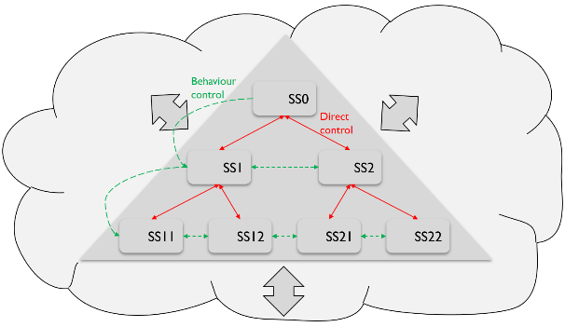
Fig. 7.
The system and all its parts interact with the environment in the same way, though these interactions are not detailed in Fig. 7..
Wikipedia defines Performance management[14] as
- “Performance management (PM) includes activities which ensure that goals are consistently being met in an effective and efficient manner. Performance management can focus on the performance of an organization, a department, employee, or even the processes to build a product or service, as well as many[quantify] other areas.

- PM is also a process by which organizations align their resources, systems and employees to strategic objectives and priorities.

Performance management is part of behaviour control[15] We need to consider local and global aspects of performance management regarding systemic homeostasis (internal stability) and goal achievement.
It is not question here to describe the many ways performance objectives set by performance management can be defined (either quantitative mathematical formula or less measurable qualitative directives) but to consider the impact of setting and enforcing these objectives.

Local aspects: Behaviour propagation in sub-systems
The first aspect concerns performance management impact at the subsystem level. When a performance measurement is put in place, the measured subsystem tends to make its best to perform as required or better. It seeks to operate optimally according to its means and current capabilities. This is the fast loop operated by the operational part and delivery management of the subsystem (VSM systems 1-3). In an industrial facility, an asset efficiency measurement would induce implementing material buffers, increase preventive maintenance, scheduling in a way that favour this measurement.
In the search to satisfy its upper management, the subsystem will try to break its current constraints to make it even better. It will start evolving to sustain and overcome its current performance achievement. This involves investment to elevate the constraints – installing an automatic feeder, modifying the facility layout - to increase throughput. This is the slow loop that changes the subsystem nature to perform better. In addition to changing itself, it also tries to induce relevant behaviour of its depending co/subsystems in order to support its performance objectives. It does so by setting performance objectives to its dependent subsystems the same way it is motivated to change itself by its upper system (Fig. 8.). Horizontal behaviour inducement is not normally achieved by performance management, because performance objectives need a recognized authority to be effectively taken into consideration. These interactions still exist through cooperation, competition and other less avowable means mentioned above…
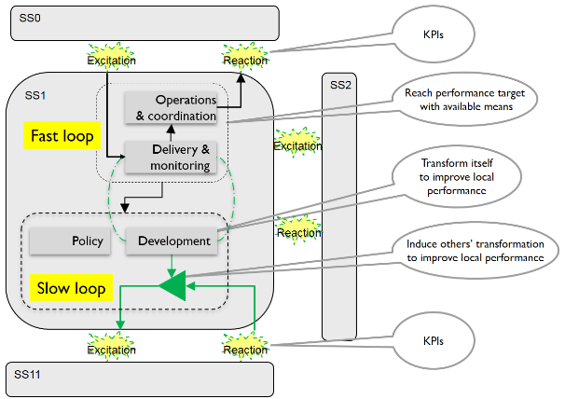
Fig. 8.
Hence, the assigned performance objectives to a subsystem are defined on the basis of their positive impact on the ability of the assigning system to satisfy its own performance assignment toward the upper system. What is important in performance management from the local view point is not only the reach of a particular measurement objective by the dependent subsystem, but also the relevance of the induced behaviour change to help fulfilling its own duty.
The corollary is that performance management need to assess primarily performance objectives relevance before the obtained results by keeping asking the questions: does this objective favourably impacts the behaviour of the lower sub-system from the upper-system view-point? Are there any undesirable side effects?

2.6 Global aspect: Overall Interactional Effectiveness
There is no need to recall that local optima lead to poor global realization. In complex organizations, the highest performance of one entity is almost always detrimental to at least another, with a likely negative impact on the bottom line. Investing in a pool of Ferrari’s and hiring experienced pilots does not help to improve traffic flow and resolve congestion, but consumes financial resources that could be invested more effectively.
If performance management stops at previously analysed local aspects, an honest assessment of the actual impact on the enterprise success will probably be disappointing.
Developed by José Gramdi since 2000, The Overall Interactional Effectiveness (OIE)[16] approach consists in defining a global metric representing the enterprise objectives to achieve its goals and orienting all functions of the enterprise to collaboratively act for elevating this metric.
These objectives are defined in terms of Social Responsibility (R) as the acceptance by non-business related stakeholders; Speed (S) that measures the system I/O lead time, directly impacting working capital needs; Quality (Q) as customer satisfaction; Overall Economic Efficiency (OEE) as the ratio of Overall Value Added (OVA) - the difference between Direct Sales Revenues (DSR) and Truly Variable Expenses (TVE) - and Overall Operating Expenses (OOE).
Fig. 9.
Based on enterprise objectives and actual operational context, highest management (VSM system 5) determines the OIE formula parameters.
The subsequent analysis is for each enterprise process to identify its impact on the components of this metric through its own characteristics. The result is a limited list of process characteristics as critical OIE factors.
Then, the relationships between processes are observed to identify the OIE dependences. The result is a refined list of OIE critical factors. (Fig. 9.)
This analysis covers VSM systems 1 to 4. It initially addresses operational processes that are readily connected to the short term aspects of OIE. Supporting and transformation processes are addressed indirectly when tackling the improvement of a process characteristic.

2.7 VSM performance management
VSM observation highlights responsibilities on performance realization and its relationship with investment decisions. For a given metric, Stafford Beer considers 3 measurements from which 3 performance values can be inferred[9] (Fig. 10.).
- Actuality is the actual realization by the measured entity. The responsibility for achieving this value is the operations and coordination domains (VSM system 1 and 2)
- Capability is the realistic, considered feasible target in a short time horizon, without investment if all is done in the current situation, taking into account the existing constraints, ensuring everything operates optimally. The responsibility for setting this value is Delivery management (VSM system 3)
- Potentiality is the desirable, mandatory target to achieve strategic objectives that Capability and Actuality will need to match in the considered future. It determines the necessary investment to secure survival in a longer time horizon. Achieving Potentiality conditions success, survival as perceived by upper management. The responsibility for setting this value is Transformation under the strategy directives of Policy (VSM systems 4 and 5).
From these values, the following performance ratios are given:
- Operational performance is the ratio of actuality on capability. It represents operations and coordination achievement toward what was designed by delivery management, using the available resources. This value goes up whenever Operations (system1 and 2) perform better or Delivery degrades capability by unwisely cutting costs (system 3).
- Latent performance or Latency is the ratio of capability on potentiality. It represents the strategic gap that needs to be closed to offer a chance to reach the strategic objectives that condition success and survival.
- Organisational performance is the product of operational and latent performance, or the ratio of actuality on potentiality. It represents the real performance toward long term expectations.
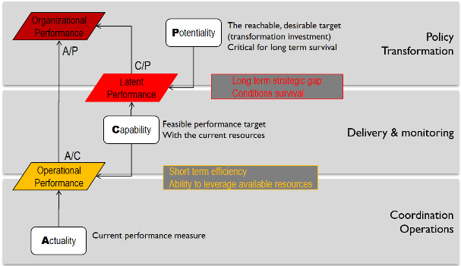
Fig. 10.
Absolute values of these measurements have limited meaning because performance indicators are arbitrary constructions, strong complexity attenuators that have no direct relationship with actual operational reality. They are more relevant when considering their relative variation (derivative) over times.
Example. A facility produces an average of 600 products per week; Its equipment has a full capacity of 20 products per hour - There are 2 equivalent machines that cannot be operated simultaneously; The facility operates 8 hours a day, 5 days a week. This facility is not constrained by the market – the company can sell everything it produces and wish to take the most of its facility. We obtain the following values:
Actuality | 600
Capability | 800 (20 x 8 x 5)
Potentiality | 6720 (20 x 24 x 7 x 2)
Operational Performance. (A/C) | 75%
Latent Performance (C/P) | 12%
Organisational Performance (A/P) | 9%
Global organisational performance results of combined operations (Operational performance) and development (latent performance). Though fanciful, the numbers are consistent with real situations in revealing that development offers more room for improvement than operations. These numbers do not mean much in absolute value, their derivative is instructive for assessing the proper alignment of system evolution toward its goals and balancing resources between operations and development.

2.8 Conflict resolution
Performance management aims at orienting behaviours for the good of the upper, commanding entity. We have seen that OIE focuses attention of the common interest of the whole organization summarized by its highest level objectives. Given the complex interactions between the concerned entities, conflicts will likely occur as shortcuts might exist to more easily reach local performance targets. More performance management is extensive and directive, more conflicts develop to cause system degradation.
It is of the highest importance to detect and resolve conflicts that will nullify the effect of a local improvement toward the organization objectives. For example, the travel department of a major company managed to buy low price ticket for its representative trip in China. It helped scoring an outstanding €/km rate, but let the person wasting 3 extra days of his work time waiting for the cheap fly in highly expensive Shanghai.
It is necessary to continuously monitor conflicts as they highlight incompatible behaviour that precisely performance management aims at streamlining on enterprise goals. Conflicts will often reveal failed assumptions about performance objective actual relevance to effectively contribute to fulfilling enterprise goals.
- Performance based digital transformation
Based on the preceding considerations, we can summarize the background for our thesis:
- Information being is perceived to be the elementary physical entity of the universe, it is definitely the major aspect of any activity. Beside its trivial and obvious contribution to support operations, Information Technology is in power to impact all enterprise functioning aspects – positively or negatively.
- Enterprises did not wait for the Digital Transformation hype to continuously improve and upgrade their IT systems. We can always identify a continuous “digital transformation process’ that can be look at and controlled – a reference model helps to make it more explicit and actionable
- Controlling digital transformation implies that responsibilities and systemic balance (operations vs development, autonomy, structure) are understood and possibly adapted - VSM provides such an analysis and diagnostic framework.
- Living complex systems operate and sustain their viability by always matching their subordinate components’ behavior to commanding components. Communication channels – interactions – convey the variety to obey this law; they can be direct / explicit and indirect / influencing: performance management is involved in the latter interaction category.
- Performance management is s tool for organizations for improving their bottom line. Local performance objectives are easily actionable by the concerned organization entities but does not always lead to better results from the whole system viewpoint because of the play of complex relationships.
- Measurement of operational performance only reveals part of the actual efficiency of the organization, neglecting its ability to evolve. VSM potentiometer takes both aspects to monitor the proper balance between operations and development.
- Digital transformation contributes to organization development.
- OIE provides a systemic framework for driving development based on global metrics to identify improvement bottlenecks and assess potential impact of development actions. OIE specifically cares about interactions between processes by assessing prospective impact on local improvement on other processes, gathering all involves parties focused on global improvement.
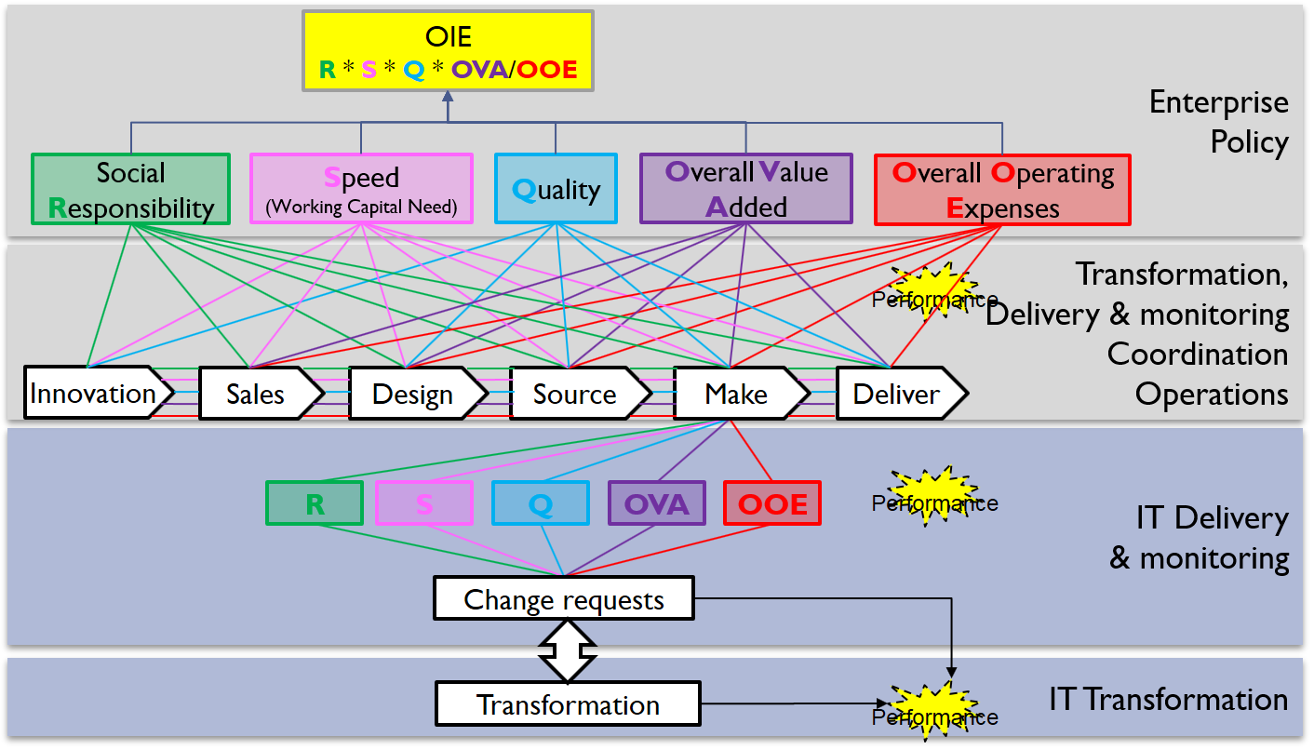
Fig. 11.
Fig. 10. extends OIE process interactional analysis with digital transformation as a transverse process that potentially impacts any performance dimension of all processes – excluding any direct impact on global performance.
The resulting inferred impact analysis of IT on OIE is the weighted list of IT OIE performance objectives as an objective reference to analyse the change requests for digital transformation. Decision and prioritization of change requests can then be based on the actual potential impact of their resolution on OIE.
This global approach to Performance management highlights three monitoring areas. At the top of the enterprise, OIE provides a metric that aims at improving its systemic behaviour for the best success of the enterprise – the right choice of the parameters must be observed at the light of the expected improvements.
Effective contribution of operational processes to OIE is locally motivated by using traditional performance management, providing that the effect of the measurement leads to the expected impact on OIE (at the enterprise level) – specifically not detrimental to another process.
The transformation processes, among them digital transformation, are monitored in the way the system evolves to allow the operational processes to better support OIE improvement. This implies effective use of resources on focused impacting transformations, and low latency for implementing change requests related to OIE performance objectives.
This process is a continuous improvement loop that responsively addresses changes of environment conditions and internal situations. The outcome of this process is the scheduling and performance of actions and transformation projects to improve the OIE performance results of the concerned processes. All aspects of transformation can be impacted, IT included. From the organizational viewpoint, Lean, 6 Sigma and Theory of Constraints methodologies can be purposely implemented depending on the desired progresses.

- Discussion

Dealing with heterogeneity.
The ongoing digital transformation results in heterogeneous IT landscape with many different interacting applications. A new application must connect to existing applications, possibly to replace part of or complete legacy applications. Many data are logically shared by several applications while being highly structuring for these applications. Interoperability and master data management are critical to IT transformation and operational performance.
This is not a trivial problem: digital transformation as generally promoted seems to imply a complete IT reengineering which is simply non achievable. Delays, cost and risk increase exponentially with size projects. Enabling smooth and robust methodology for a manly incremental transformation is critical for the best performance of this process. It hassle-free functional cutting and cropping for flexible and evolving urbanization needs integration policies, methods and middleware capable of addressing misaligned semantic domains (organisational entities, applications):
- Established machines communication language
- Comprehensive, scalable, flexible and deterministic and effective master data management
- Enterprise led interoperability design and implementation
- Flexible functional modularisation that stick on organization

IT delivery performance management
IT performance traditionally focuses on operating services: compliance to service level defined in terms of reliability, availability, responsiveness… ITIL is a well-known reference in that matter.
Though this service notion can very well be expanded to the transformation process, IT performance is not often managed in relation to the ability to serve enterprise evolution in search of reaching its goals.
As emphasised above, it is not easy/feasible/realistic to measure the IT contribution to enterprise success. Instead IT delivery shall be measured in terms of overall latency for addressing prioritized requirements. Priorities are set according to concerned business performance requirements own priorities.

Application to IT budget and investment
IT projects are mainly motivated and budgeted on practical and tactical business cases, even if some strategic wording is added up in the mix for packaging a sound financial decision dossier.
There are many formulas to guestimate IT return on investment for industrial systems. The truth is that IT by itself hardly brings demonstrated tangible value that can even less be proved subsequently. The proposed approach does not seek to provide hard fabricated numbers that would release budget authorization from its responsibility.
The reasoning is not to consider the absolute value of IT, but to assess the need for adapting the effort intensity dedicated to IT at the light of the latency acceptation and trade-off with other priority spending and investments, knowing that information is the essence of the main part of the enterprise itself and is what is added to raw material and energy to make sellable products.
The OIE analysis allows to focus IT improvement and investment to help pushing up this strategic metric while measuring the tactical delivery performance.
The potentiality is given by the prioritized requirements backlog, the capability what can be realistically done. It is then easy to arbitrate a budget adjustment knowing the induced latency and impacted OIE performance objectives, hence the enterprise success.
- Use case
This real life example partially illustrates performance management aspects considered in this study. It concerns the R&D department of a large company with 2000 researchers spread into a decade of independent business units (BU) in the process of deploying a sophisticated Electronic Laboratory Notebook (ELN) by the software vendor consulting team.
The strategic objective was to boost innovation by increasing research productivity. The assumptions where that the software should help automating experimentation and allow to share acquired data and knowledge among researchers.
The ELN deployment process appeared to be rather slow and expensive: developing experimentation procedures was painful, selling the solution to researchers was tough. In addition (or in consequence?), the project involved sensitive relationships between business, IT department and software provider.
Fig. 11. shows the 4 viable entities involves in the process: The enterprise as a whole (the Group), the R&D department within the Group, the R&D IT department and the contractor (software vendor/integrator).
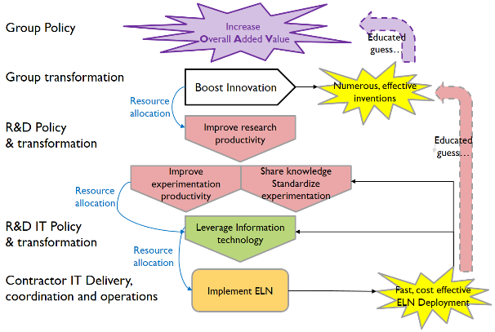
Fig. 12.
ELN deployment is supposed to boost the innovation process that is deemed important to increase the group Overall Added Value.
Boosting innovation is translated into increasing research productivity: more effective inventions. This objective is translated into experimentation productivity though automation and sharing knowledge, both supported by standardization of experimentation procedures.

Performance indicator (PI) example: user coverage and responsibility
Fig. 12. exposes the dynamic performance values and responsibility for a simplistic PI “number of users served” (as mentioned above, a more actionable PI would be the derivative of this value).
At the bottom, the actual number of users already served is 88 – this is the responsibility of the contractor which acts as the system 1 of the R&D IT transformation VSM (it is also a VSM on its own).
The maximum number of users who could be served is 135. This number includes the 88 already served and the 47 who are waiting for the contractor to implement at least one function. This number is determined by the IT department’s ability to motivate R&D BU managers for involving number of users on actual experimentation activities.
The total number of potential users is 2000, which is believed to be the ultimate, desirable target for fulfilling the strategic objective. However, R&D management only allow deployment to some business units gathering 380 users.
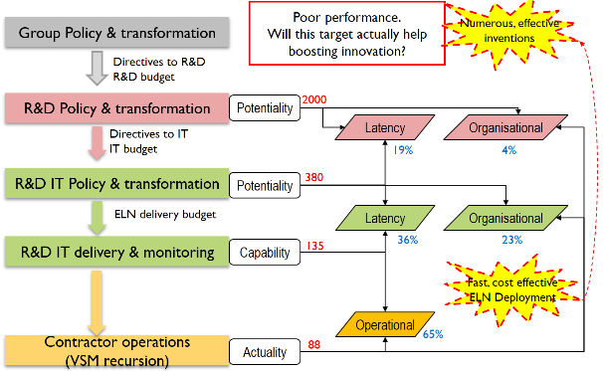
Fig. 13.
This gives the following performance values: Operational contractor performance is 65%; latency of the R&D IT department is 36 %, making its organisational score of 23%; Latency of R&D department is 19%, making its organisational score of 4%. Different conclusions could be drawn from these numbers, but the important thing is to make explicit the scores at every level of responsibility.

Conflict resolution
As discussed above, a low global score is not a problem by itself. Because a useful metric was not considered (for example Overall Added Value for the new products of the year), there were no means to trustfully assess the possible impact of ELN deployment to innovation.
However, the strongly felt slowness and the sensitive relationships are indications of underlying conflicts that must be investigated. Fig. 13.is an “evaporating cloud”[17] from the theory of constraints toolbox to expose the conflicts and elaborate resolving injections.
The upper branch exposes the management assumptions to justify ELN deployment. Improving experimentation productivity was rightly deemed necessary to serve the objective of boosting innovation, expressed as numerous, effective inventions.
It finally emerged during the ELN project that researchers where reluctant to share their data and knowledge, and that they needed to conduct their experimentation with the least constraints possible. These two aspects directly conflict with management assumptions, while they seemed totally justified by the forgotten “creativity” dimension of innovation.
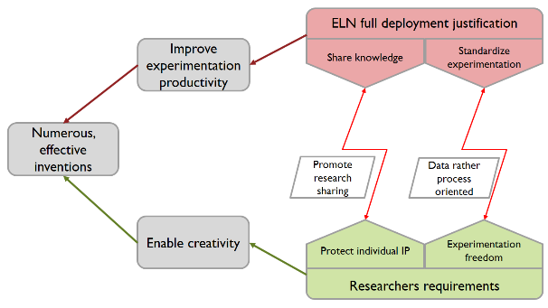
Fig. 14.
This needed to be addressed by the proper injections. Shared knowledge against protecting individual intellectual property might be mitigated by promoting research sharing with appealing incentives (academic scientists are eager to share their findings to collect citations as an essential criterion for their career development). Standardization of experimentation is extremely constraining when addressing the detailed procedural aspects. A mitigating injection might be to focus on consistent data collection and abandon automation, allowing to keep most flexibility of manual handling still allowing data sharing. Higher level knowledge aspects could be addressed by internal research publishing incentive (much like academic research) complemented with appropriate company level intellectual property protection. This example shows that Theory of Constraint evaporating cloud as a formal conflict resolution method while Lean management Hoshin Kanri / Nemawashi processes certainly help to prevent such situations to occur or to raise spontaneous mitigation changes.
- Conclusion
Continuous digital (IT) transformation ought to support enterprise ongoing transformation, possibly by leveraging new technologies
Performance management is an essential component in this process to focus efforts on enterprise goal / objectives and to properly allocate resources and budgets.
System approach helps understanding the role, benefits and pitfalls of performance management. Complexity management is a key aspect of operating successful organisation; it involves behaviour control to match the increasing complexity top to down the organization.
Overall Interactional Effectiveness directs organization entities toward common quantified objectives, allowing to focus transformation efforts to support these objectives.
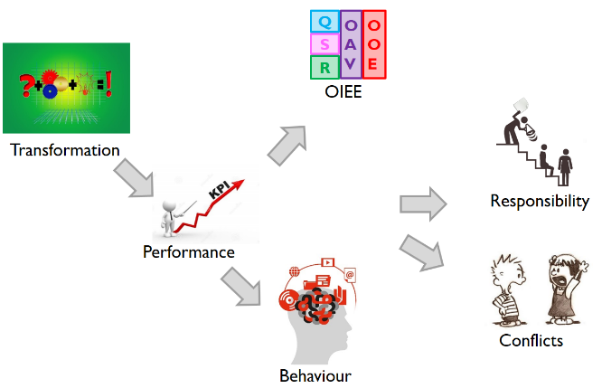
Fig. 15.
Performance management operational targets must be considered for their actual impact on monitored entity’s behaviour, while put in a broader context of the potential target that would allow to reach the objectives. This highlights the managerial responsibilities of balancing operations and transformation resources for optimizing short and long terms sustainability and progresses.
Finally, conflicts resolution is the corollary of performance management that exacerbates competitive behavioural traits that tend to ignore other’s problems to satisfy the mere local performance assignment.

It is important to consider the proposed approach in line with a common mind-set concerning human behaviour as an autonomous, selfish entity wo fight for his personal advantage and survival. Though proved and actionable, this aspect of human nature is not the only way humans deal with their social environment. Unselfish prosocial behaviour, spontaneously seeking community interest is a major enabler of sustainability in organizations. Too much pressure on performance achievement inhibits this capability and exacerbates selfish, opportunistic behaviour and resulting conflicts that ultimately endanger the system stability and survival.[18]
Is it then possible to minimize the need for intermediate control as subsystems naturally seek the common good and avoid unnecessary conflicts, making performance management both simpler and more efficient by supporting instead of driving enterprise operations and transformation.

Acronyms
BU Business Unit
CEO Chief Executive Officer
CIO Chief Information Officer
DSR Direct Sales Revenues
ELN Electronic Laboratory Notebook
HR Human Resources
IOT Internet of Things
IT Information Technologies
PI Performance Indicator
OVA Overall Value Added = DSR – TVE
OEE Overall Economic Efficiency
OIE Overall Interactional Effectiveness
OOE Overall Operating Expenses (all expenses but TVE)
R&D Research and Development
TVE Truly Variable Resources (without any cost accounting expenses repartition)
VSM Viable System Model

References

[1] T. Stonier, Information and the Internal Structure of the Universe. London: Springer London, 1990.
[2] S. C. Brown and J. A. Greene, “The Wisdom Development Scale: Translating the Conceptual to the Concrete,” J. Coll. Stud. Dev., vol. 47, no. 1, pp. 1–19, 2006.
[3] “Reference model,” Wikipedia, the free encyclopedia. 24-May-2016.
[4] B. Nuseibeh and S. Easterbrook, “Requirements Engineering: A Roadmap,” in Proceedings of the Conference on The Future of Software Engineering, New York, NY, USA, 2000, pp. 35–46.
[5] “Wiley: Ackoff’s Best: His Classic Writings on Management - Russell L. Ackoff.” [Online]. Available: http://eu.wiley.com/WileyCDA/WileyTitle/productCd-0471316342.html. [Accessed: 17-Jun-2016].
[6] W. R. Ashby, An introduction to cybernetics. New York, J. Wiley, 1956.
[7] K. R. Popper and S. K. R. Popper, Objective knowledge: an evolutionary approach. Clarendon Press, 1972.
[8] “Wiley: Decision and Control: The Meaning of Operational Research and Management Cybernetics - Stafford Beer.” [Online]. Available: http://eu.wiley.com/WileyCDA/WileyTitle/productCd-0471948381.html. [Accessed: 17-Jun-2016].
[9] “Wiley: Brain of the Firm, 2nd Edition - Stafford Beer.” [Online]. Available: http://eu.wiley.com/WileyCDA/WileyTitle/productCd-047194839X.html. [Accessed: 17-Jun-2016].
[10] “Wiley: The Heart of Enterprise - Stafford Beer.” [Online]. Available: http://eu.wiley.com/WileyCDA/WileyTitle/productCd-0471948373.html. [Accessed: 17-Jun-2016].
[11] “Wiley: The Fractal Organization: Creating sustainable organizations with the Viable System Model - Patrick Hoverstadt.” [Online]. Available: http://eu.wiley.com/WileyCDA/WileyTitle/productCd-0470060565.html. [Accessed: 17-Jun-2016].
[12] P. Masai, P. Parrend, N. Toussaint, and P. Collet, “Is the Lean Organisation a Complex System?,” in CS-DC’15 World e-conference, Tempe, United States, 2015.
[13] “Gestion de la performance dans les systèmes industriels.” [Online]. Available: https://www.researchgate.net/publication/278734452_Gestion_de_la_performance_dans_les_systemes_industriels. [Accessed: 17-Jun-2016].
[14] “Performance management,” Wikipedia, the free encyclopedia. 11-Feb-2016.
[15] L. J. Hayes, E. M. Dubuque, M. J. Fryling, and J. K. Pritchard, “A Behavioral Systems Analysis of Behavior Analysis as a Scientific System,” J. Organ. Behav. Manag., vol. 29, no. 3–4, pp. 315–332, Aug. 2009.
[16] “La Boucle Vertueuse de l’Excellence - Lexitis Editions.” [Online]. Available: http://www.lexitiseditions.fr/fr/la-boucle-vertueuse-de-lexcellence-1.html. [Accessed: 17-Jun-2016].
[17] H. W. Dettmer, Goldratt’s Theory of Constraints: A Systems Approach to Continuous Improvement. ASQ Quality Press, 1997.
[18] L. Stout, “Cultivating Conscience: How Good Laws Make Good People,” The Brookings Institution. [Online]. Available: http://www.brookings.edu/research/papers/2010/12/conscience-stout. [Accessed: 18-Jun-2016].

The word “digital” is incorrect actually: it relates to fingers (digitalis in Latin) involved in prehistoric abacus calculators, or to the prehistoric seven digits Nixie tubes display; nevertheless, this term will be used throughout the article to designate the information technology aspect of enterprises ongoing development.

