Applying the Operations Management Information models
  - Introduction
The models in ANSI/ISA–95.00.02 clause 6 are used to handle information exchange for any operational activity categorized in this standard as Production, Maintenance, Quality Test and Inventory operations:
- Operations definition information
- Operations schedule information
- Operations performance information
- Operations capability information and Process segment capability information
This annex provide some examples on how these models can implement common information content within and across these different categories.
The examples are based on the Operations Schedule model. Other models usage can be easily deducted from this one as they are basically subsets of this most elaborated model. Indications in italic are possible usage names for the scheduling elements.
  - Production Operations
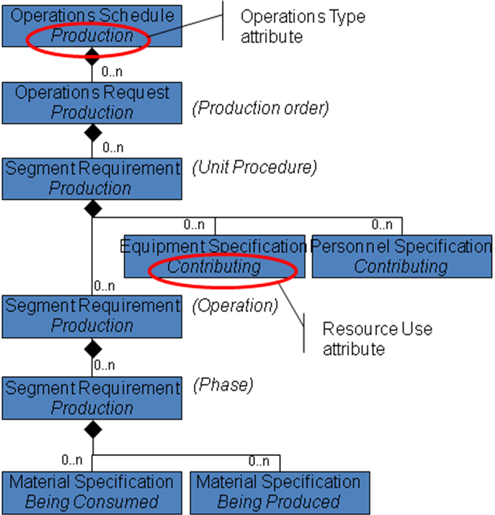
The operations schedule applied to Production Operations is a straightforward generalization of the original production related model from the initial version of this standard.
The facing example illustrates a detailed production scheduling pattern based on the ISA88 procedural model: the production order is hierarchically split into unit procedure, operations and phases.
The “contributing” Equipment and Personnel specifications represent the resource allocation; according to ISA88, they are attached to the “Unit Procedure” segment requirement.
The “being produced” and “being consumed” material specifications are attached to the “Phase” segment requirement.

  - Quality Operations

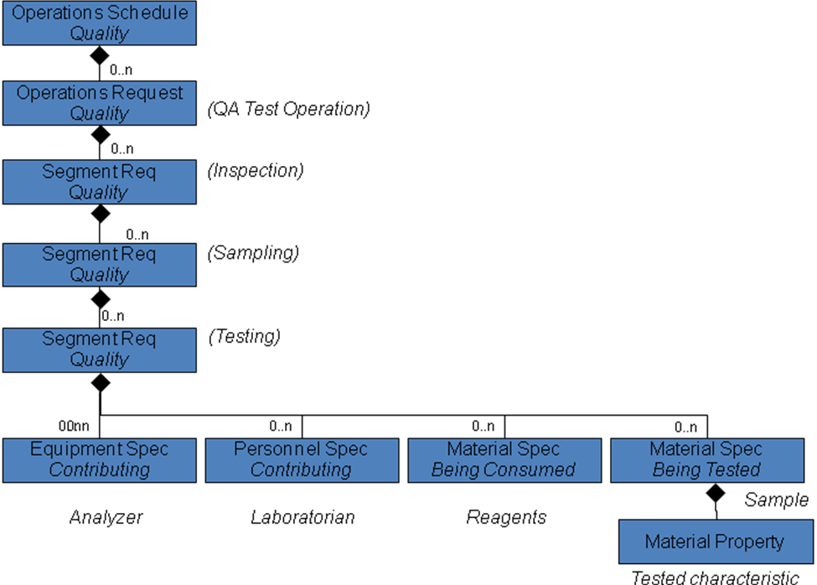
3.1 Testing a material
The operations schedule applied to quality operations can address the testing of the different types of resources.
The facing example illustrates a detailed material testing scheduling pattern: the QA Test operations is hierarchically split into inspections directing sampling, sampling to feed tests and testing itself.
Only test segment related resources are illustrated.
The “contributing” Equipment and Personnel specification represent the resources involved in the test realization (analyzers, laboratorians)
The “being consumed” material specification corresponds to the reagents and other substances used for performing the test.
The “being tested” material specification should correspond to the sample taken and identified as a lot at the upper level segment. The latter holds the properties that will be assessed during the test. If the results expected from the test do not match directly the properties, they can be specified (and later collected in an operations performance report) as segment data. This 4 layered scheduling scheme is a complex example; practical application will often be simpler.
The facing example shows the possible matching of the standard models to particular structures of an ERP system.
The consistent, neutral terms in the standard match the solution and business specific names.

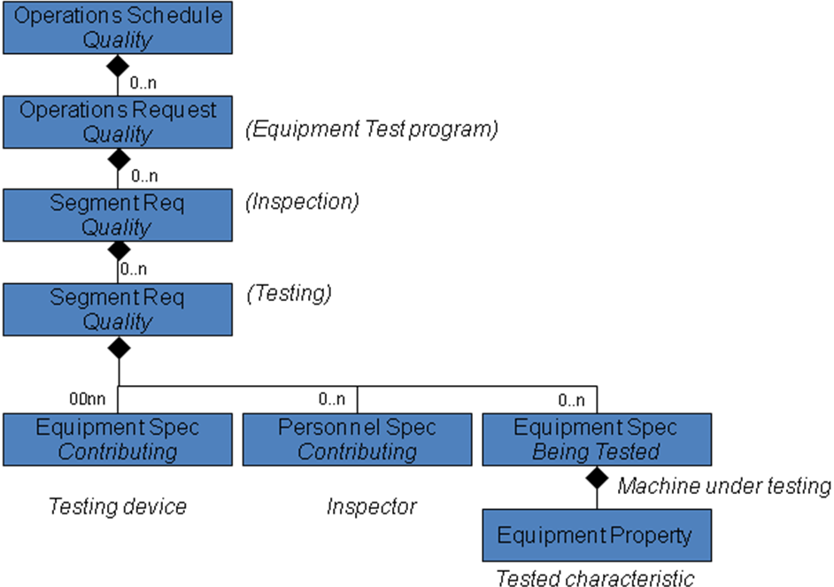
3.2 Testing an equipment
A second example of quality operations is the test of the capabilities of a piece of equipment.
The operations request corresponds to a test program for a piece of equipment. It is split into inspections and tests.
The “contributing” equipment and personnel specifications represent the resources involved in the test achievement (testing device and inspector).
The “being tested” equipment specification represents the target for the test (this could also be a physical asset resource type).

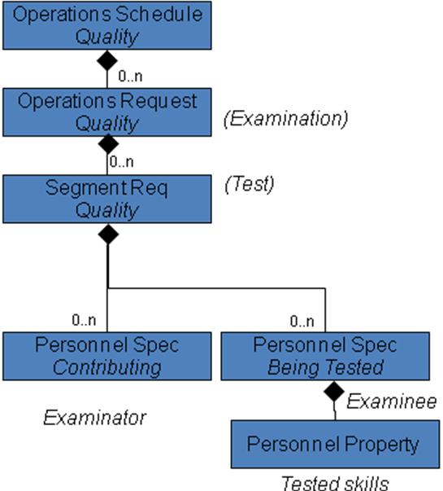
3.3 Testing a person
A last example of quality operations is the assessment of the capability of a person.
The operations request corresponds to an examination, which is split into individual tests.
The “contributing” personnel specification represents the examinator.
The “being tested” personnel specification represents the examinees who are going to pass the exam.
The properties are the specific skills that will be assessed during the course of the examination.
  - Maintenance operations
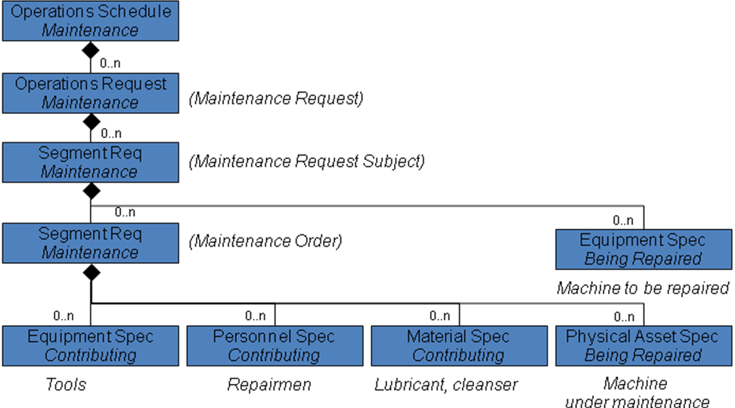
The operations schedule applied to maintenance operations can be implemented as shown on the facing figure.
The operations request corresponds to a maintenance request from a user regarding particular role-based equipment (the user may not know the machine serial number)
The first level segment is needed to specify the equipment that needs to be repaired.
From this contextual information about the maintenance work to be performed, the last level segment holds the maintenance order applying to the physical asset that is actually concerned (the “being repaired” physical asset specification)
The “contributing” equipment, personnel, and material specifications represent the resources (tools, repairmen, lubricant) involved in the maintenance job.
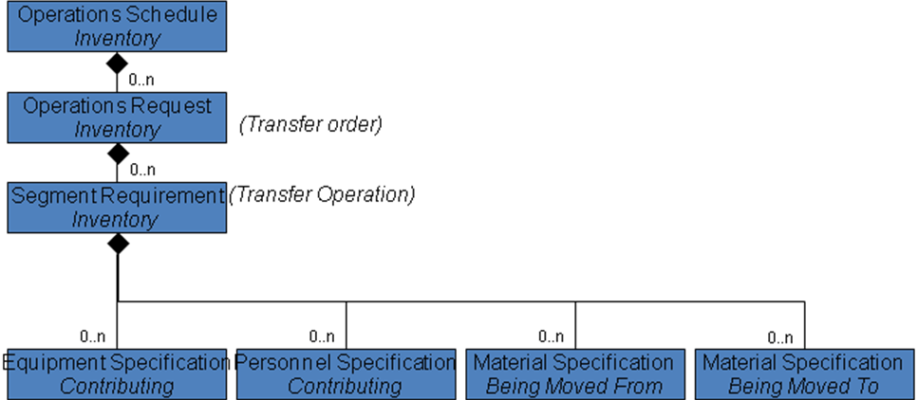
  - Inventory operations
The operations schedule applied to inventory operations can address the many logistics and material handling situation.
The facing example illustrates a detailed transfer schedule pattern: the transfer order is split into transfer operations that move materials from one place to another.
The “contributing” Equipment and Personnel specifications represent the resources involved in the transfer realization (pallet truck, driver)
The “being moved from” and “being moved to” material specifications corresponds to the material movement itself. This scheme allows dispatching material from one place to many, or from many to one place, including possible losses during the transfer.
  - Mixed operations
Finally, the operations schedule model can handle mixed types of operations. The operations schedule, operations request and segment requirement can be specialized or not:
- A “mixed” operations schedule can hold mixed or specialized operations requests
- A “mixed operations request can hold mixed or specialized segment requirements
- A “mixed” segment requirement can handle multiple resource specifications that would normally appear in specialized segment.
In the figure, the segment requirement specifies
- the material movements needed to fulfil the corresponding operations (inventory operations category)
- the resources for the production; the material information should include the dispensed material and other material those transfer would not need to be specified (liquid substance available from fixed pipes)
- the quality related resources that are involved during or at the end of the production operation
This modelling allows handling the exchange of information between business and execution systems in a consistent and simple way.


